**MINI PROJECT – II**

**(2019-20)**

# Voice Recognition System

# (Python)

**SYNOPSIS**



**Institute of Engineering & Technology**

## Supervised By:

**Asst. Prof Sharad Gupta**

## Department of Computer Engineering & Applications

**Team Members**

Palak Agarwal

(171500213)

Swapnil Saxena

(171500353)

Priyanka Gupta

(171500241)

**TABLE OF CONTENT:**

**Abstract……………………………………………………………… i**

**Acknowledgement………………………………………………….. ii**

**Declaration…………………………………………………………. iii**

**1. Introduction…………………………………………………….… 1**

1.1. Overview……………………………………………………….. 2

1.2. Motivation…………………………………………………….... 3

1.3. Problem Statement………………………………….….............. 4

1.4. Objective………………………………………………………... 5

**2. Software Requirement Analysis………………………………… 6**

2.1. System Analysis………………………………………………... 7

2.2. Classification…………………………………………….……... 8

2.3. Create database…………………………………………............. 9

2.4. Connecting microphone………………………………………… 10

**3.Requirements…………….……………..……………………........ 11**

3.1. Hardware……………………………………………………...... 11

3.2. Software………………………………………………………... 12

3.3. Operating system………………………………………………. 13

3.4. Application…………………………………………………….. 14

3.5. Technology…………………………………………………….. 15

**4. Results……………….…………………………………………... 16**

**ACKNOWLEDGEMENT**

It is our immense pleasure to acknowledgement the assistance of number of people without whose help this would not have been possible. Firstly, we would like to express our respect and gratitude towards **Mr. Sharad Gupta**, our guide for giving us this opportunity and providing us with full support and invaluable guidance in every way possible, throughout the project.

We would also like to thank the group members for their constant support extended for the completion of this project. It would not have been possible without the efforts and co-operation of our group members. This project has provided us technical as well as general knowledge and given maturity of thought and vision. Lastly, I would like to thank our friends and respondents for their support and willingness to help is through the project.

Swapnil Saxena (171500353)

Palak Agarwal (171500213)

Priyanka Gupta (171500241)

**About the Project:**

* Speech is the most basic means of adult human communication. The basic goal of speech processing is to provide an interaction between a human and a machine.
* **Speech recognition** allows the machine to catch the words, phrases and sentences. Natural language processing is to allow the machine to understand what we speak, and speech synthesis to allow the machine to speak.
* In this project we make use of the above feature to create an Automatic Speech Recognition System to make our systems make use of our voice commands to perform real life tasks.
* For example sending an E-mail, telling what time is it, searching for something on Wikipedia and opening files present on our Systems etc.

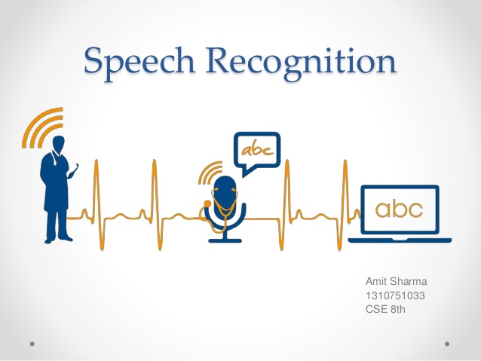

**Motivation:**

* We were motivated to create this project through inbuilt AI like Microsoft Cortana, Google Assistant and we are quite interested in creating our own AI Voice Recognition System using Python as our primary language.
* We were also intrigued to work on this project because of its many future prospects and applications.
* Speech recognition is also used in automatic dialogue systems. Such as typically automated telephone answering systems hold information about a specific domain and can be interacted with in natural speech.
* A user's speech is detected, analyzed, appropriate queries are made or activities performed, and an answer is generated, which is then once again converted into speech with the speech synthesizer.
* Apple's Siri and Google Now are examples of such dialogue systems.

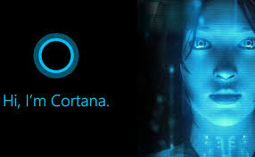

*Our Motivation*

**Technology Used:**

1. **Hardware:**

* Microphone
* Speaker
* 1 TB storage
* 8 GB RAM
* Desktop

1. **Software:**

* Visual codes
* Python packages

1. Anaconda
2. Pandas
3. Numpy
4. Pyttsx (speech to text engine)

* Operating System (Windows, Linux)

1. **Language Used:**

* Python programming language

**FUTURE PROSPECTS:**

* 1. Voice to Speech Conversion over using text commands.
  2. Interactions between Machines and Humans made easy. Better AI system functionalities.
  3. Voice recognition enables consumers to multitask by speaking directly to their Google Home, Amazon Alexa or other voice recognition technology. By using machine learning and sophisticated [algorithms](https://whatis.techtarget.com/definition/algorithm), voice recognition technology can quickly turn your spoken work into written text.
  4. Speech recognition can allow students with learning disabilities to become better writers. By saying the words aloud, they can increase the fluidity of their writing, and be alleviated of concerns regarding spelling, punctuation, and other mechanics of writing.

**TARGET USER AND SCOPE:**

Basically the users targeted:

### In-car systems

* Simple voice commands may be used to initiate phone calls, select radio stations or play music from a compatible smartphone, MP3 player or music-loaded flash drive.

### Military

* In these programs, speech recognizers have been operated successfully in fighter aircraft, with applications including: setting radio frequencies, commanding an autopilot system, setting steer-point coordinates and weapons release parameters, and controlling flight display.

### Usage in education and daily life User:

* Speech recognition can allow students with learning disabilities to become better writers. By saying the words aloud, they can increase the fluidity of their writing, and be alleviated of concerns regarding spelling, punctuation, and other mechanics of writing.

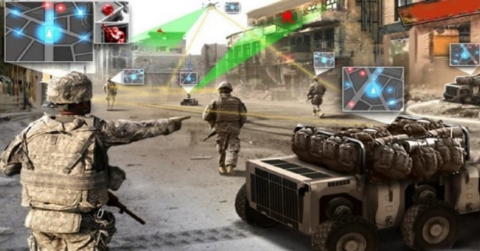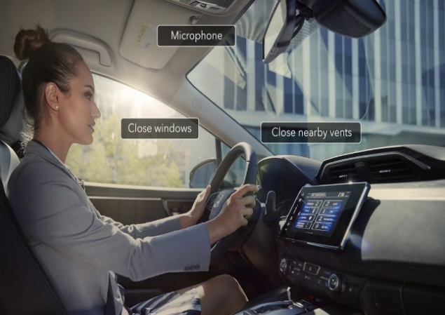

**HOW WILL IT LOOK LIKE IN WORKING?**

**REFERENCE**

<https://www.tutorialspoint.com/artificial_intelligence_with_python/artificial_intelligence_with_python_speech_recognition.htm>

<https://www.youtube.com/watch?v=Lp9Ftuq2sVI>

Introduction to voice computing in Python by Jim Schwoebel